#### Title: Comprehensive Literacy Strategies for Emerging Readers and Writers: Project Core to Building Bridges

Tuesday October 15, 2024

8:30 Details and Introductions

9:00 Project Core Introduction

Review of Learning Outcomes and handouts.

What is Project Core?

Getting Started

Universal Core Vocabulary

10:00 Break

10:15-10:45 **Opportunities to Learn Using Universal Core**

11:00-11:30 Conditions of Literacy Learning video

Activity: conditions of Learning Reflection form

11:30-12:00 Dynamic Learning Maps

12:00-12:45 Lunch

12:45-2:00 Building Bridges

2:00-2:15 Break

2:15-3:00 Building Bridges, Tar Heel Reader

3:00-3:15 Demo: How to Read and Write to Tar Heel Reader

3:15-3:30 Evaluation **Please give us your feedback!**

PRESENTERS: Karen Carl, TVI, Jane Herder, TVI, and Rubecca Wilson, TOD/HH

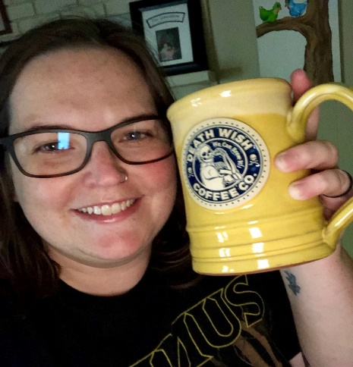Rubecca has a MS in Education of the d/Deaf and Hard of Hearing from Missouri State University, and a BS in Communications, Sciences, and Disorders from the same university. She is a certified teacher of the deaf and hard of hearing. Rubecca is currently a second-year doctoral student in education with an emphasis on curriculum and instruction at Evangel University in Springfield, MO. Rubecca has worked as an educator of the d/Deaf and hard of hearing for seven years. She has worked as a classroom teacher for a district program and as an itinerant teacher serving an entire district. She also provides early intervention services for the d/Deaf and hard of hearing population. Rubecca is a consultant and instructor with the Missouri DeafBlind Project since 2018 and is an all-around groovy human!

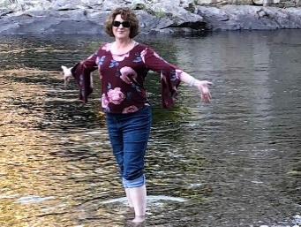Karen is a retired Teacher of the Visually Impaired from Fort Zumwalt School District.  She has been working with the visually impaired since 1991.  She has a BS Ed. in Elementary Education from the University of Missouri-Columbia, a M.Ed. in Specialized Reading, a CTVI from University of Missouri-St. Louis, a CTDB from East Carolina University and a certificate in CVI from UMass-Boston.  She is currently working on coursework in Early Intervention at UM-Columbia. She also serves as an Educational Consultant with the Missouri DeafBlind Project (MoDBTAP) and is an all-around delightful human!